Employee Accident Investigation Form

Your Name: | Date of Incident:
Job Title: | Date Reported:
Client: | Time Incident Occurred:
Supervisor: | Time Work Started Day of Incident:
Sex:  Female  Male Date of Birth: | Name of witness (if any):
What were you doing at the time and how did the injury occur? (Include tools or equipment in use, task being performed, etc.):
___________________________________________________________________________________________
___________________________________________________________________________________________
___________________________________________________________________________________________
___________________________________________________________________________________________
___________________________________________________________________________________________
___________________________________________________________________________________________

Where, exactly, did it happen? ___________________________________________________________________
___________________________________________________________________________________________

What parts of your body were injured?
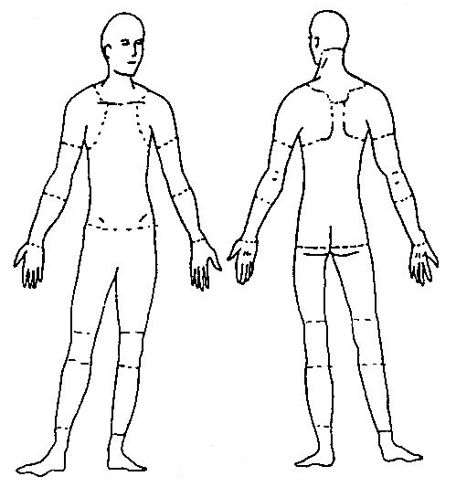
Was medical treatment sought?  Yes  No, treatment was declined at time of incident
Has this part of your body been injured before?  Yes  No
If yes, when? ___________________________________________________________
Name of Treating Physician: _______________________________________________________
Did you have any of the following treatments?  MRI  Surgery  Diagnostic Testing  Other
If “Other”, describe in detail: ___________________________________________________________________
___________________________________________________________________________________________

STAFF SOURCE will make available Temporary Modified Duty when possible. If you have been released by your physician to return to work on Temporary Modified Duty or without restriction, you are required to inform Human Resources.
I understand that providing false and misleading information to STAFF SOURCE or STAFF SOURCE’s insurance company is subject to criminal prosecution.
I understand that I must contact Staff Source prior to seeking medical treatment. I understand if I choose to seek treatment without contacting Staff Source I will be responsible for any cost incurred.

Your signature: | Date:

